**Book Cover Using Canva**

1. INTROCTION
   1. Overview

Use the design brief to communicate your marketing goals and allow the designer to exercise their skill. For example, you might say, “The goal is for cover design is to convince romance readers that this book will be like the other books they like, and so they should pick it up off the shelf.

* 1. Purpose

As a physical component of the book, the cover is a skin, a membrane, and safeguard: paper jackets protect hardback from scuffing and sun, damage, while paperback covers not only hold the book together but also keep its sheets clean and safe from tearing.

Aligning your text and imagery in the center of the page can create a sense of harmony and order. When other elements of the design are used to evoke certain emotions, symmetry can help strengthen their impact. Examples of symmetry in book cover design.

1. Problem Definition & Design Thinking
   1. Empathy Map

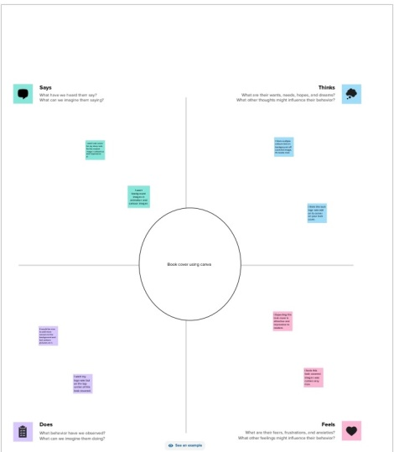

2.2Ideation & Brainstorming Map

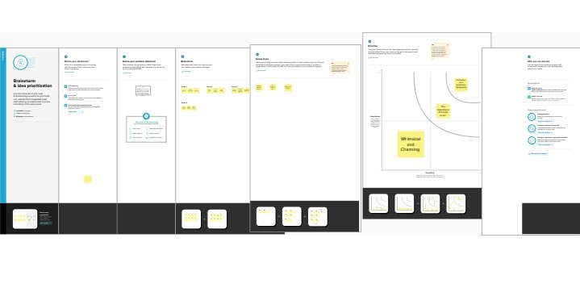

1. RESULT



1. AdvantageS & disadvantages

Advantages:

* Portable-easy to carry with you
* Cost-effective
* Flexible spine-easy to read
* Has a quick turnaround
* Low-cost

Disadvantages:

* Heavy/less portable
* Customers find they’d rather pay less for a paperback
* Prone to damage
* Publishers do not adhere to a standard size
* Less durable; the cover and interior can be easily damaged

1. application

* book cover us used for all government and defense related works
* A book cover is used to publish a health record
* Book cover is very useful for displaying educational books

1. conclusion

A well- designed book cover is important because it serves as the face of the book, and entices readers to purchase it. A book cover uses design elements like colour, font, images or illustrations to reflect key themes that are relevant to the text, and helps readers to understand a little more of what it’s about.

1. future scope

* Canva is sure to be the best business card creator in the future.
* The best designers get more exposure through canva.
* This application of canva Will be used more in the future.